**Name: Shashwat Tripathi**

**D10A 58**

**Batch C**

**Computer Network Lab**

Aim: To write a program to create two nodes using ns2.

1) Open text editor and write the code

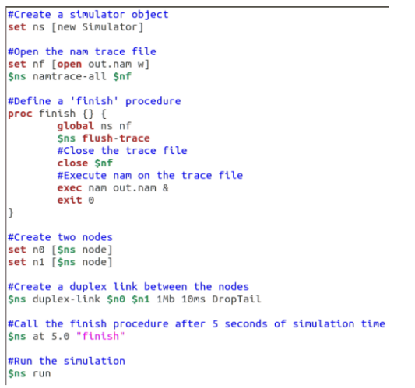

2) Save it with the extension “.tcl”



3) Open the file location in terminal and execute the code using the

command “ns filename.extension”

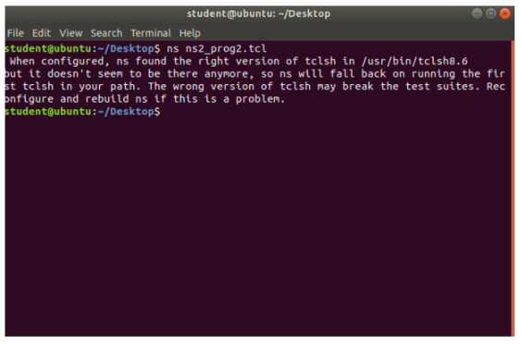

Execution:

